PADE Beyond Fundamentals Series – January and February 2022
Homework for Workshop 1 – January 12, 2022

Note: this should take no longer than 5 minutes!

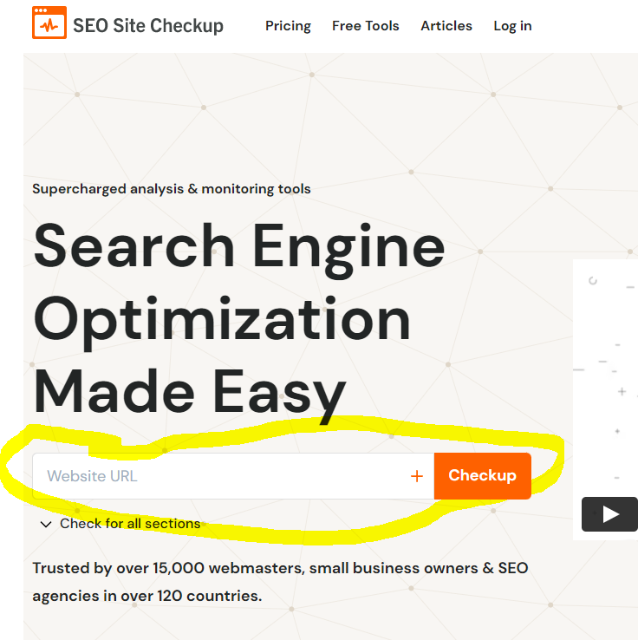
- Go to https://seositecheckup.com/
- Enter your website url in the open field and click on Checkup
- Wait until the report is generated – this usually takes just a minute.
- Save the report by copying and pasting the information into Word or taking screen captures of all information.
- Send your report to ipetri@strategicmoves.ca
- BONUS: Anyone who submits their report will receive a tailored prioritization of key actions to improve their search engine visibility.

